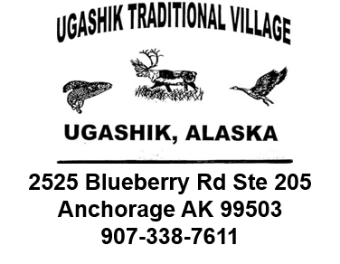

Application Form for American Rescue Plan Act Housing Improvement Program funding for Ugashik Traditional Village Tribal Households.

CHECKLIST
Please make sure your application satisfies all the criteria specified in the below checklist.
 | YES | NO
Fully completed applicant information (Section 1)
Provide detailed information documenting how funding will be used for housing improvement. (Section 1.1)
Fully completed vendor information: who will be contracted to do the work on your home. (Section 1.2)
Fully completed Vendor/Supplier Information
(Section 1.3)
Duly completed documentation showing ownership of your home. (Section 2)
If work has already been done between the dates of March 11, 2021, and present day, please provide copy of invoices already paid for housing improvement done.
Tribal Member Number (We have it on file, if you don’t remember it)

- APPLICANT INFORMATION
Tribal Member Name: |  | Tribal Member Number:
First Name: |  | Last Name:
Full Street Address:
City, State and Zip Code
Mailing Address
City, State, Zip Code
Email Address
Phone #
Mobile #

1.1. Describe how the ARPA funding will be used for housing improvement
(Please explain in detail the work you would like to have done or have had done.

1.2. Document vendors and contractors that will provide the work and supplies for your housing improvement.
(Please provide information on who will do the work, where materials and supplies will be purchased, etc.) If approved work has already been done, please provide receipts of materials purchased and proof of invoices paid.

1.3. VENDOR/SUPPLIER INFORMATION
Labor Contractor contact information: (physical address, phone number, email, etc. - please provide all details)

Company Name:
Address:
City: State: Zip Code
Phone #

Company Name:
Address:
City: State: Zip Code
Phone #
Email

Material Supplier information:

Company Name:
Address:
City: State: Zip Code
Phone #
Email

Material Supplier information (cont.):

Company Name:
Address:
City: State: Zip Code
Phone #
Email

- HOME OWNERSHIP INFORMATION
Mortgage Company Information: (for proof of home ownership)

Mortgage Company Name:
Address:
City: State: Zip Code
Phone #
Account #

If home is fully owned, provide documentation: Property tax bill, copy of deed, etc.
Dates of Residency:

ADDITIONAL DOCUMENTS

Please provide, along with your application, the following documents:
  - A copy of your deed of ownership and/or mortgage statement
  - Copy of cost estimate of work being done (including materials and labor).
  - Copy of cost estimate of supplies needed (if not included in the work estimate)
  - Copy of all receipts of materials purchased, and labor invoices paid.
  - A copy of your Tribal I.D. and one other Photo I.D.

Signature:

Date (MM/DD/YYYY):

Funding will be disbursed directly to vendors contracted to do the improvements to your home, and to suppliers of materials needed for said improvements. The amount of funding determined by the Federal guideline requirements and the UTV Council has been set at $10,000 for every tribal member who owns their home.

If within the past year, you have already had home improvement work done (March 11, 2021, up to the present day), your expenses can be reimbursed by UTV. Please provide the following:
- Description of work done.
- Copies of Invoices for labor and materials.
- Proof of payment to vendors for materials, supplies and labor.

If within the past year you had home improvement work done and did the work yourself, you can be reimbursed for materials and supplies only.

